ALPHA ARTS AND SCIENCE COLLEGE



AI – WEATHER WISE API

TEAM LEADER : SANTHOSH V

NM Id: 2DDB40BD165B340BD344CF710C467332

TEAM MEMBER : LOKESH D

NM Id: 1795AAC2E51792EB6D14206D176DAED7

TEAM MEMBER : UDHAYA NARAYANAN M

NM Id: A802C36EF26499D4BDA241153C88C

TEAM MEMBER : KANCHANA DEVI G

NM Id: 53FA89CA301568383384C7248B1BB228

TEAM MEMBER : SHIVANI A
NM Id: FDC9429F2745BBAAAF14BF091EAA9F

OBJECTIVE:
The aim of this project is to build an AI-powered weather assistant that helps users check weather conditions, understand weather information, and get personalized weather recommendations.

KEY POINTS :

- REAL TIME WEATHER : Provides current weather information for selected locations through an external weather API.

- AI-POWERED RECOMMENDATIONS: Generates weather summaries, activity suggestions, and clothing guidance using Google Gemini.

- USER-FRIENDLY INTERFACE: Provides a clean UI with intuitive controls for easy weather search and navigation.

- SECURE DATA MANAGEMENT: Handles user details and favorite locations safely and efficiently through secure authentication.

- BUILT WITH MODERN TECH: Uses React, Node.js, Express.js, MongoDB, and Mongoose for reliable and scalable performance.

- API INTEGRATION: Connects external weather services with Google Gemini to provide useful and intelligent weather insights.

- EXPANDABLE DESIGN: Easily adaptable for new features like detailed forecasts, weather alerts, notifications, and enhanced personalization.

PLATFORM & TECHNOLOGY USED :

The project is developed as a web-based application to provide weather information through a modern browser. The following technologies and platforms are used:

- REACT: Used for building the interactive and component-based user interface.

- NODE.JS: Used as the JavaScript runtime for backend development.

- EXPRESS.JS: Used for developing RESTful APIs and handling backend routes.

- MONGODB: Used as the NoSQL database for storing user and favorite-location data.

- MONGOOSE: Used for defining database schemas and interacting with MongoDB.

- GOOGLE GEMINI: Used for generating AI-powered weather summaries and recommendations.

- WEATHER API: Used to retrieve real-time weather information for selected locations.

- JWT + BCRYPT: Used for authentication and secure password handling.

- THUNDER CLIENT: Used for API development and testing.

IMPLEMENTATION / PROCESS:

- HOME PAGE

  - Displays the main WeatherWise interface and weather search functionality.
  - Acts as the main entry point for users to access weather information and AI insights.

- WEATHER SEARCH

  - Users can search for a city or location.
  - The application retrieves current weather information through the external weather API.

- WEATHER DETAILS

  - Displays available weather information for the selected location.
  - Presents weather data in a simple and understandable format.

- AI WEATHER INSIGHTS

  - Weather information is processed using Google Gemini.
  - Generates easy-to-understand weather summaries.
  - Provides activity suggestions and clothing guidance based on weather conditions.
- FAVORITES & PERSONALIZATION

  - Users can save their preferred locations.
  - Users can view, update and delete saved locations.
  - Favorite locations are associated with the registered user.

- USER AUTHENTICATION

  - Provides user registration and login functionality.
  - Uses JWT for authentication.
  - Uses bcrypt for secure password hashing.

- REST APIS

- Provides structured backend APIs for the frontend.
- includes authentication, weather, favorite-location and AI recommendation routes.

- ERROR HANDLING

  - Handles API and service failures.
  - Provides fallback behavior when external services are unavailable.

- TESTING & DEPLOYMENT

  - APIs are developed and tested using Thunder Client.
  - The React application provides the frontend interface.
  - services connect the application with MongoDB, the weather API and Google Gemini.

OUTPUT / RESULT:

PROJECT STRUCTURE:

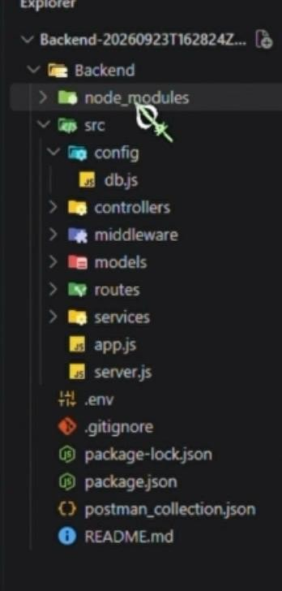

REGISTER / AUTHENTICATION

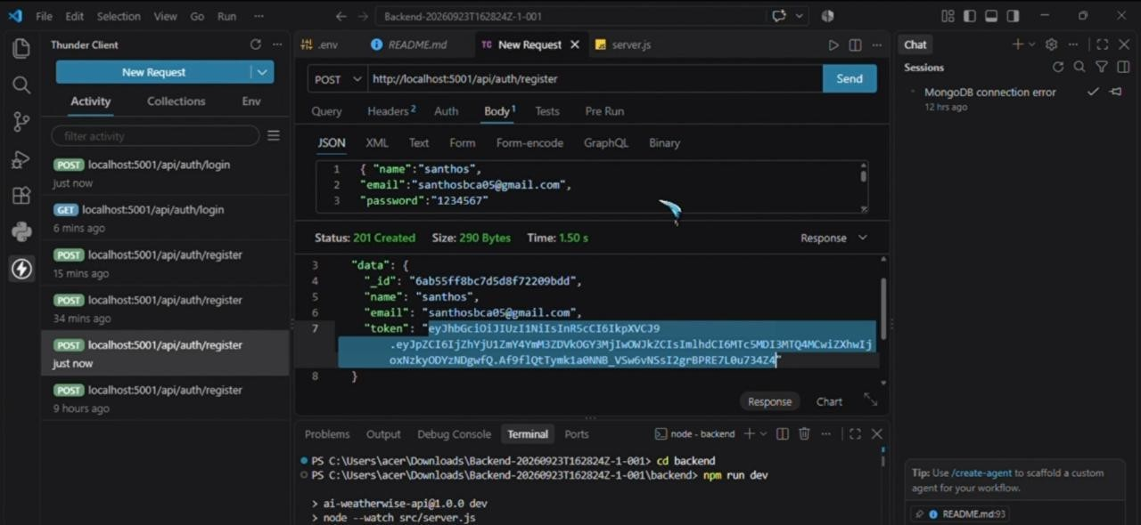

LOGIN / AUTHENTICATION

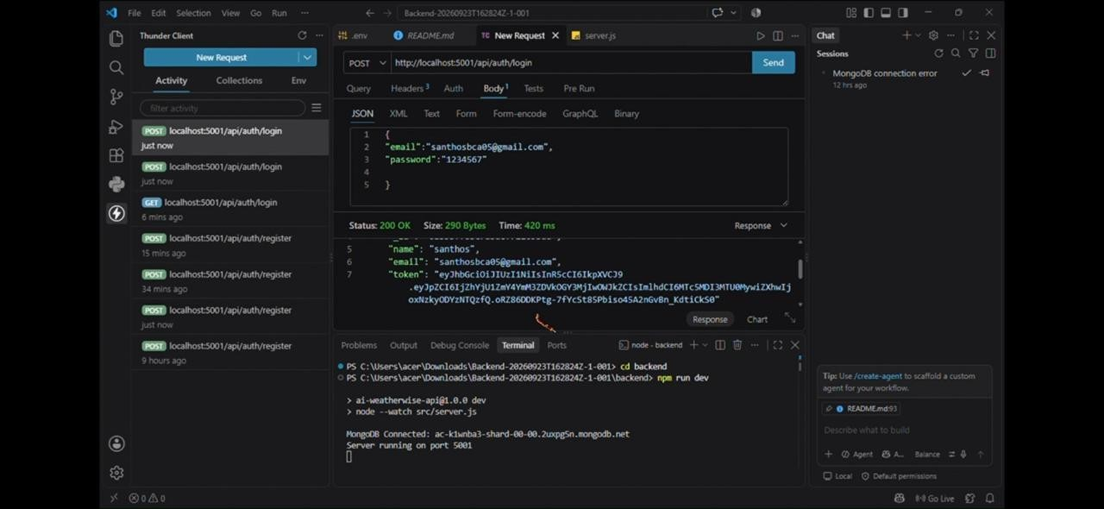

WEATHER - SUMMARY
( ERROR STATUS )

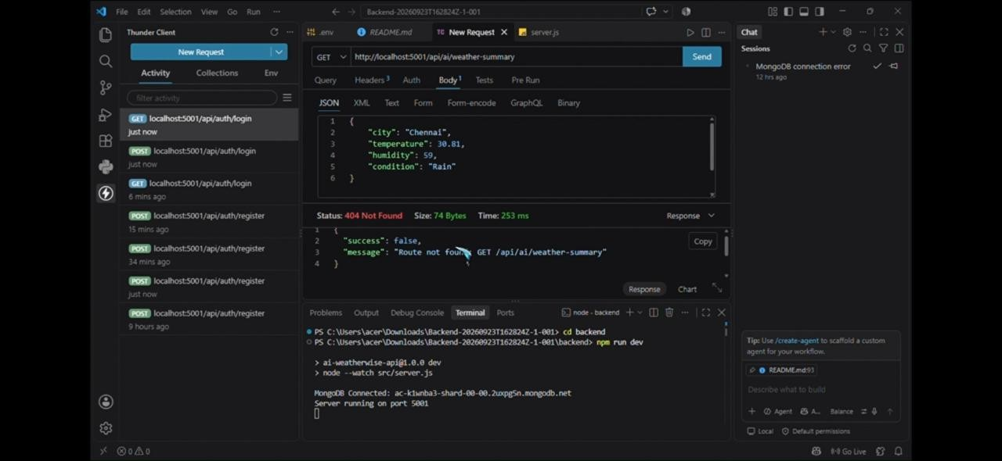

CORRECTED STATUS :
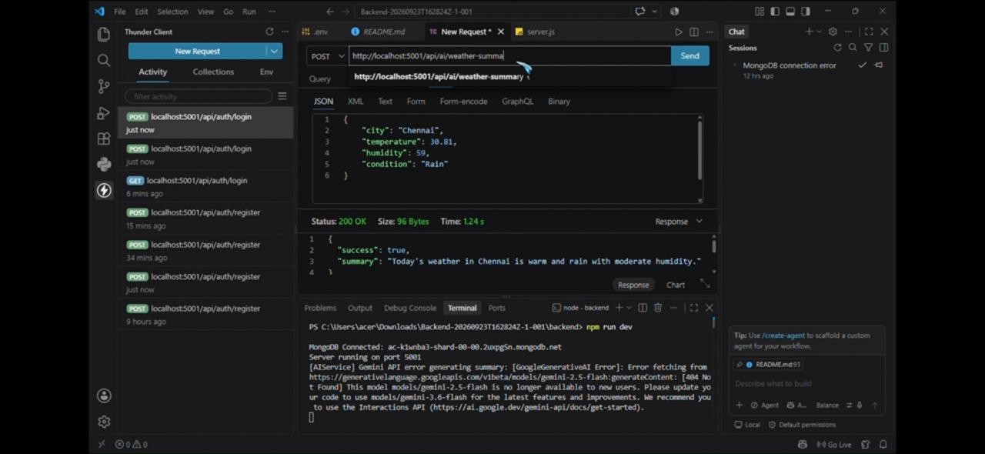

WEATHER RECOMMENDATION

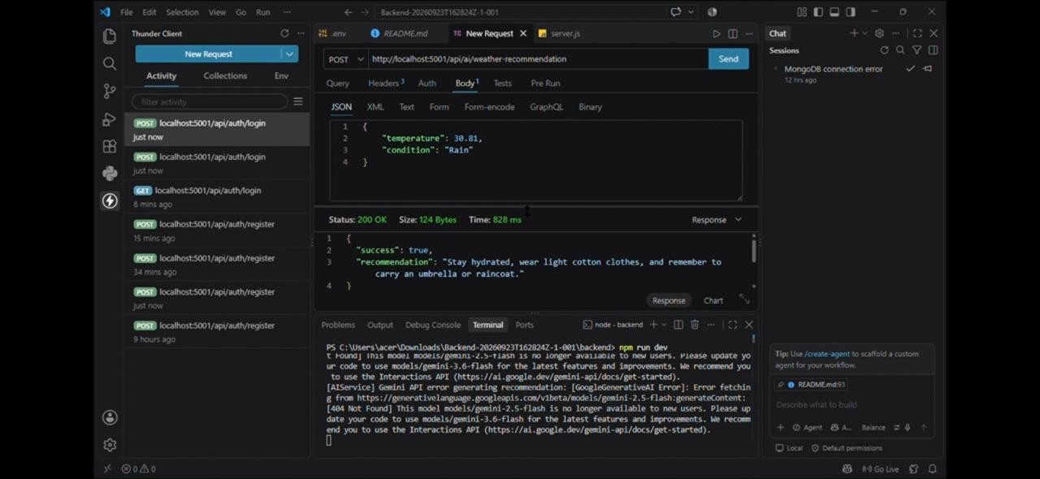

DEMO VIDEO LINK :

https://drive.google.com/drive/folders/19w0zPAPmK9RcHNlPDJP9V-BN2MNNWVXs?usp=sharing

GIT HUB LINK :

https://github.com/santhoshbca02/AI-WeatherWise-API.git

